4th March 2020

**YOKOHAMA to Launch Overseas Sales of GEOLANDAR CV G058, a Mud & Snow Grand-Touring Tyre for Crossover SUVs**

YOKOHAMA announced today that this spring it will gradually expand marketing of its GEOLANDAR CV G058 around the world, the latest addition to its GEOLANDAR line-up of tyres for SUVs and pick-up trucks. The new GEOLANDAR CV G058 is a grand touring tyre for crossover SUVs. The new tyre is available in 43 sizes, ranging from 265/50R20 107V to 205/70R15 96H.

The GEOLANDAR CV G058 is a successor to the GEOLANDAR SUV unveiled in 2012. In addition to continuing its predecessor’s suitability for city driving, the tyre has been enhanced to make it a grand touring tyre that delivers greater comfort on long drives. In addition to improved basic performance features of a highway tyre, such as safety and noise reduction, the new GEOLANDAR CV G058's total performance has been elevated by enhancing its wear resistance and fuel efficiency. Like its predecessor, the GEOLANDAR CV G058 has secured the M+S (mud & snow) designation that indicates excellent performance even during a heavy snowstorm.

The tyre’s tread pattern features YOKOHAMA's proprietary “sipe-based pattern”, which increases edging efficiency. The tread pattern incorporates several YOKOHAMA technologies that improve the tyre’s total performance: 2D/3D combination sipes enhance the tyre’s resistance to uneven wear while also improving traction on wet and snow-covered roads; the use of four combination grooves further enhances traction while also preventing hydroplaning; and the tread pattern’s five-pitch variation eliminates annoying pattern noise. The use of a new compound based on YOKOHAMA’s cutting-edge silica technology contributes to stable driving in various road conditions, including roads with low surface temperatures caused by rain or snow. In addition, a newly developed profile achieves a wide and flat contact shape that further improves the tyre’s durability and resistance to uneven wear. The above features have raised the new GEOLANDAR CV G058 performance across the board. Compared with its predecessor GEOLANDAR SUV, wet braking has been improved by 12% and wet handling stability 13%, road noise has been reduced by 34% and pattern noise by 9% (both figures based on comparisons of noise energy reduction rates). In addition, vertical axial force* has been reduced by 7%.

* The force applied to the tyre when going over bumps or other protrusions. Lower force applied to the tyre by a bump or protrusion contributes to a smoother, more comfortable ride.

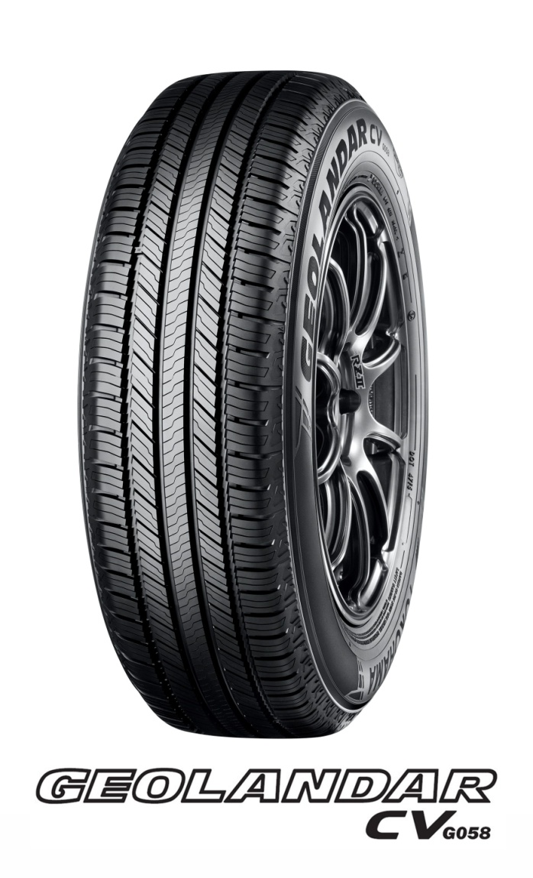

GEOLANDAR is YOKOHAMA’s global brand of tyres for SUVs and pickup trucks. The GEOLANDAR line-up includes a wide range of tyres, from highway-terrain to mud-terrain tyres. In addition to the new GEOLANDAR CV G058, the brand’s tyres targeted for use on crossover SUVs include the GEOLANDAR X-CV, for high-performance crossover SUVs.

**Tread Pattern Increases Resistance to Uneven Wear, Wet-grip, and Quietness**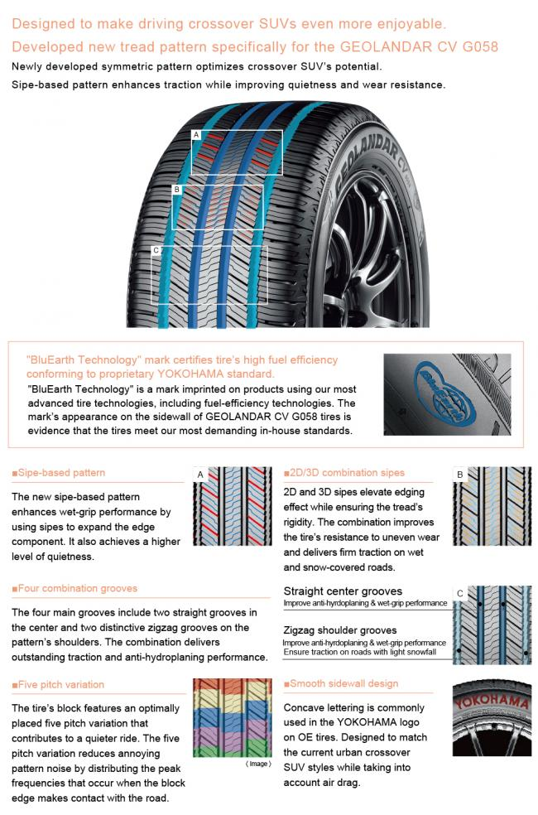

**New Compound Keeps Rubber Supple to Ensure Superior Braking on Cold Surfaces**

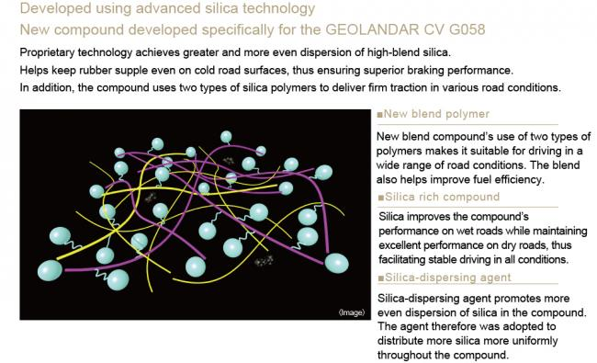

**Wide & Flat Profile Developed to Enhance Wear Resistance and Reduce Uneven Wear**

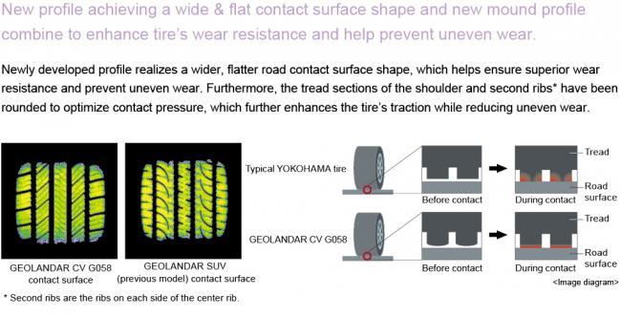

**Available Sizes**

